**PROJECT REPORT TEMPLATE**

1. **INTRODUCTION**

***1.1 OVERVIEW***

The Electric vehicles (EV) is not new , but it has been receiving significantly more attention in recent years.

A vehicle that can be powered by an electric motor that draws electricity from a battery and is capable of being charged from an external source and have an electric motor instead of an internal combustion engine.

Advances in both EV analytics and battery technologies have let to increased automotive market share.

However, this growth is not attributed to hardware alone.

The modern mechatronic vehicles marries electrical storage and propulsion systems with electronic sensors, controls, and actuators, integrated closely with software, and data analysis, to form a comprehensive transportation solution.

***1.2.PURPOSE***

Advances in all these areas have contributed to the overall rise of EV’s, but the common thread that runs through all these elements is data analytics.

The new EV’s are combined electrical storage and propulsion systems with electronic sensors, controls, and actuators, integrated closely with software, secure data transfer to form a comprehensive transportation solution.

1. **PROBLEM DEFINITION AND DESIGN THINKING**
   1. ***EMPATHY MAP***

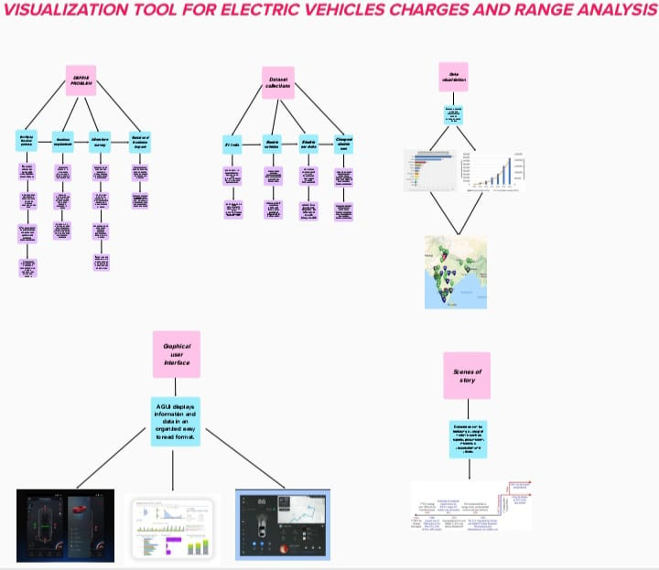

* 1. ***IDEATION ND BRAINSTORMING MAP***

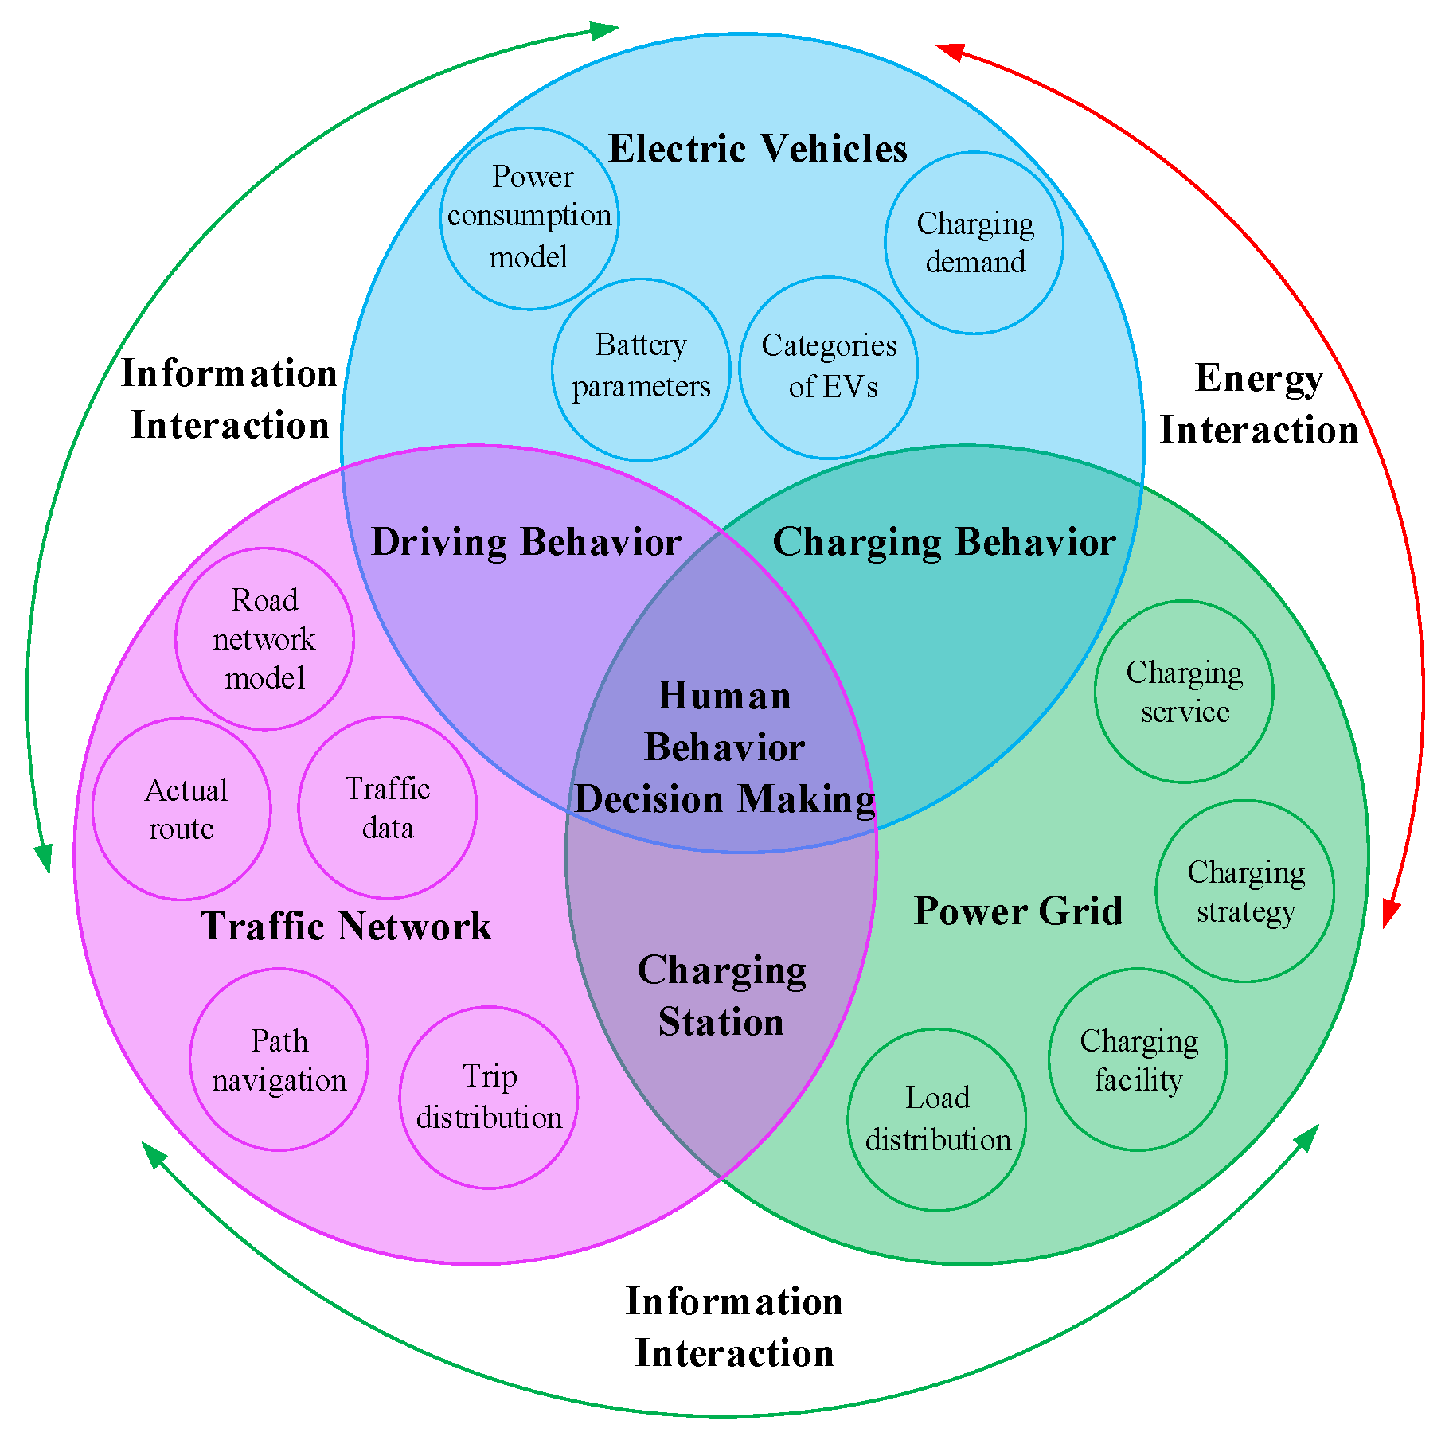

1. **RESULT**

According to our project we can analyse the profitability analysis by the area type and power level. Representative data on energy consumption, arrival times, occupation, and estimated profitability of 22,200 charging stations in Germany. The observed patterns are translated into compact empirical models that allow working with the results without the burden of the large-scale datasets.

1. **ADVANTAGES AND DISADVANTAGES**

|  |  |
| --- | --- |
| ***ADVANTAGES*** | ***DISADVANTAGES*** |
| * Eco friendly | * High initial cost |
| * Renewable energy source | * Charging station limitations |
| * Less noise and smoother motion | * Recharging takes time |
| * Cost-effective | * Limited options |
| * Low maintenance | * Less driving range |

1. **APPLICATIONS**

Electric vehicles are a type of vehicles that is powered by an electric motor instead of an internal combustion engine. They are used for a variety of transportation purposes, including personal and public transportation, as well as for commercial and industrial purposes.

1. **CONCLUSION**

This project shows that the progress that the electric vehicle industry has seen in recent years is not only extremely welcomed, but highly necessary in light of the increasing global greenhouse gas levels.

1. **FUTURE SCOPE**

The future potential of electric vehicles is enormous. The obvious starting point for these vehicles is the charging station. This is however only the first step in a potential journey which will see charge banks and other industrial areas as well as homes and cities. The future scope of electric vehicles is therefore massive.

1. **APPENDIX**

https://www.sciencedirect.com/science/article/pii/S258900422201906X